
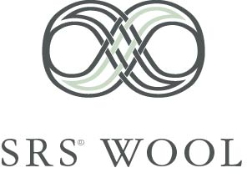

Breeding True Density & Length in Advanced Alpacas
By Dr Jim Watts and Janie Hicks based on their research into alpacas
Australia 1996 to 2005 and Peru 2001.
2 November 05

Introduction

For the Australian alpaca industry in general and specifically today’s alpaca owners to prosper financially from their alpaca investment in the future, developing a commercial alpaca will be determined by the success or otherwise of delivering products that competitive markets demand.

The Australia and New Zealand alpaca scene is different to most other alpaca owning countries. The small human population limits the future growth of an industry underpinned by lifestyle considerations, since Australia now contains the largest herd of alpacas outside of Peru. In per capita terms, Australia already has approximately 25 times more alpacas than the US. Australians have and continue to focus on the quality of the wools they breed.

Fibre based products today deliver in Peru a third-world subsistence level of financial return to the grower. Hence, there are orders of magnitude increases required in the financial viability of today’s alpacas.

The success of alpaca fibre breeding for the qualities of density and length using the SRS® Breeding System indicates with good confidence that the required level of financial return is there to be had.

Improvements from SRS® Alpaca Breeding

From the SRS® breeding programme carried out at Coolaroo over the last nine years, it is clear that the alpaca has a bright future as a fibre growing animal.

As previously stated, the SRS® Breeding System has the characteristics of fibre density and length underpinning its breeding selections. This system has delivered very positive results over seven years. Table 1. below summarises these results. These results are taken off fully mature animals of over 3 years of age.

Table 1. Follicle and fibre measurements (mean ± standard error) of selection fibre density and length of fibres.

Trait | Before SRS® selection | After 7 years of SRS® selection
Follicle density (per mm²) | 25.8 ± 1.5 ª | 53.3 ± 2.6 ^{b}
Follicles per group | 24.3 ± 0.3 ª | 36.3 ± 0.2 ^{b}
Primary fibre diameter (µm) | 39.4 ± 0.9 ª | 33.7 ± 0.7 ^{b}
Secondary fibre diameter (µm) | 29.3 ± 0.9 ª | 24.0 ± 0.6 ^{b}
Number of animals | 20 | 22

Follicle density per mm has doubled whilst at the same time primary and secondary fibre diameters have fallen. The gross fleece weights of these animals each year have increased and simultaneously each kilo has become markedly more valuable given the manufacturers work on micron levels.

Fleece weights in the first fleece or weaner populations are showing exceptional improvements with young animals growing to manufacturing fleece length ie 100mm within 6 months of birth and therefore providing growers two harvests annually. Again micron diameter in first fleeces have dropped significantly.

The question is what can be achieved in the next seven years? Estimates are made in the final section of this article.

Why Does SRS® Select for Density & Length rather than Micron and Weight

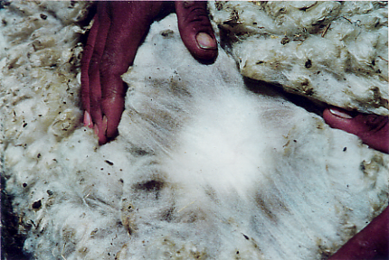
Fibre breeding reasoning is surely rather straightforward. Micron determines fleece value. The lower the micron of the fibre grown the higher the value received for that fleece by the grower. So, if you select for lower micron by using “trusty” histograms, and if you select sensibly and consistently from your histogram information, surely you will breed animals with lower micron and hence of more value! That is all OK, except lower microns also means lower weight of fibre produced, all other things being equal. So while the lower microns produce higher value, does the higher micron return compensate for the loss in return from the reduced fibre weight grown?

Fig 1. A low microning fleece showing poor levels of density and length. On follicle measurement this animal measured half the follicle density of its paddock mate seen in next slide.

However, surely we can be a bit cleverer and make breeding selections based on micron and weight, so that while the micron of the fibre goes down, the weight of the annual fibre harvest per animal increases. Unfortunately, nature is not that simple. Selecting for fleece weight can produce a number of outcomes. Increasing the fibre weight of fleeces grown will mean selecting for a number of fibre outcomes. The first outcome is increasing the diameter of the fibres, because for the same number of fibres, increasing the diameter of the fibre increases the fleeces weight, all other things being equal. Secondly, decreasing the yield of clean fibre (which means growing fibre with a higher grease and suint content) will increase fleece weight. Thirdly, increasing the length of the fibre and fourthly increasing the number of fibres on the animal’s body will increase fleece weight also. The problem is, which of the four outcomes will the genes select? Or will it be a mixture of outcomes?

The first of these outcomes indicate breeding confusion. Breeding selection is for a decrease in micron on one hand while selecting for an increase in micron on the other. No further comment is needed. The second outcome has already been experienced in Australia, by way of the importation of Vermont sheep from the US in the 1890’s. These sheep were low yielding super-high-grease-content sheep, which had seriously deleterious consequences for the Australian merino industry. The third and fourth outcomes, increase fibre length and increased number of fibres, are positive fibre breeding outcomes.

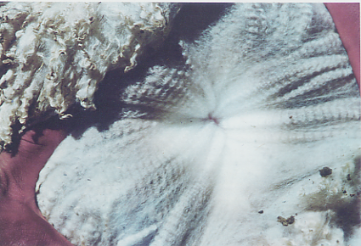

Fig 2. Similar micron to the above fleece but showing good markers for true density and length. See Fig 3.

It is argued here that selecting for micron from histograms and measured fleece weights is conceptually problematical. There is a further problem. The actual measurements from the histogram include factors for statistical error, an alpaca’s age and the nutrition it has received. Selecting for weight also includes factors of nutrition, foreign and vegetable matter, and shearing consistency. Clearly, it is very difficult, if impossible, to remove these factors so that a clear fibre-only micron or weight measurement is produced from which important breeding selections are to be made.

These issues indicate real questions about breeding selections based on microns measurements from histograms and fleece weights produced from shearing sheds. Further, real life results in the merino industry over many years confirmed that alternative breeding methods were required.

SRS® and Density and Length

At the Coolaroo Alpaca Stud, selecting for the visual fleece markers used in the SRS® breeding system have produced a marked increase in the fibre density (the number of fibre follicles per square millimetre). These findings (refer Table 1:) are consistent with Moore’s pre-papilla cell hypothesis of the regulation of wool follicle formation and fibre size (Moore et al, 1998).

From a fibre outcome point of view, it would seem that selecting for fibre density means that the only breeding gain, that would appear to be achieved is the same fibre diameter but more fibres. However, selecting for density in merino sheep, angora goats and now alpacas at the Coolaroo Alpaca Stud has confirmed that breeding for density has many other outcomes. These include:

- less ‘guard hair’ produced, which means less medullation, less prickle and higher quality garments
- longer and thinner staples, which means more fibre and better textile manufacturing
- secondary follicle branching, which means dramatically more fibres
- reduced primary and secondary fibre diameters, means reduced micron.

And as it turns out, selecting for density is selecting genes which produced organised fibre producing skins. And it is through organised fibre growing skins that alpaca fibre production can be enhanced to levels which produce first-world financially viable alpacas.

Measuring fibre density also has its problems, though far less so than microns and weight. Once, an alpaca is born the number of fibre follicles on the fibre-bearing surface of the alpaca is fixed. So as the animal grows, the follicle density will decrease as the animals surface area increases. However, age factors developed over many years of measuring density in merinos and angoras allow adjustments to be made when alpacas are density tested before they are fully grown. Though clearly, by taking measurements when an animal is mature, any doubts are removed. And the level of secondary follicle branching associated with density will not change over the life of the animal or under different nutritional regimes, like histogram and fleece weights do.

It should be stated that, the SRS® breeding system’s visual markers are very accurate in determining superior density animals, simply by visually appraising the animal. Actual density testing is only really required for the odd very good animal or after a few years as a monitor of progress of selection in the progeny.

What is the Fibre Density of Better Alpacas

A survey of follicle and fibre traits of 63 Huacaya adult alpacas in Peruvian herds was recently conducted (Watts and Hicks, 2002). The animals sampled were considered by the owners as the best in their herds. Follicle density of the animals averaged 42.7 follicles per square millimetre with an average of 32.7 follicles per follicle group.

The highest density alpaca was an 18 month old male with 75 follicles per square millimetre. An animal of similar high density, a 14 month old male, was identified in the Coolaroo herd in May 2004. It has a density of 91 follicles per square millimetre, 41 follicles per group and has a mean fibre diameter of 18.5 microns.

Density and “False Density”

Fibre density is considered one of the important traits when determining the quality of an alpaca’s fibre. Certainly, alpaca judges in the show ring often mention higher fibre density, along with fibre descriptive terms like finer, softer, more lustrous and so on, when appraising an animals fleece qualities. However, on what basis are judges and others quantifying density?

As previously stated, the SRS® Breeding System is based on selection for density and length. Hence, appraising density is one of the key capabilities of the SRS® fleece marker system, which has been developed over 30 years, as the only non-measured accurate method of appraising an animal’s fibre density. An animal with superior SRS® fleece markers will be a superior density animal to one with inferior SRS® fleece markers.

Grabbing fleece in your hand and squeezing it (hand grab), or touching both sides of an alpaca with open palms and imparting inwards pressure to appraise the resistance (touching both sides), or lifting up the fleece (lifting) to obtain a weight/density indication are all methods that are likely to lead to a “false density” assessment. The “hand grab” method may be an indication of entangled, unaligned and disorganised fibres that have encapsulated air pockets that falsely give a feeling of density. Obtaining greater resistance with the “touching both sides” method is likely to be an indication of an animal exhibiting much higher diameter primary fibres than one where less resistance is felt. A “lifting” test may provide an assessment of greater suint content and higher diameter fibres than higher density or more fleece.

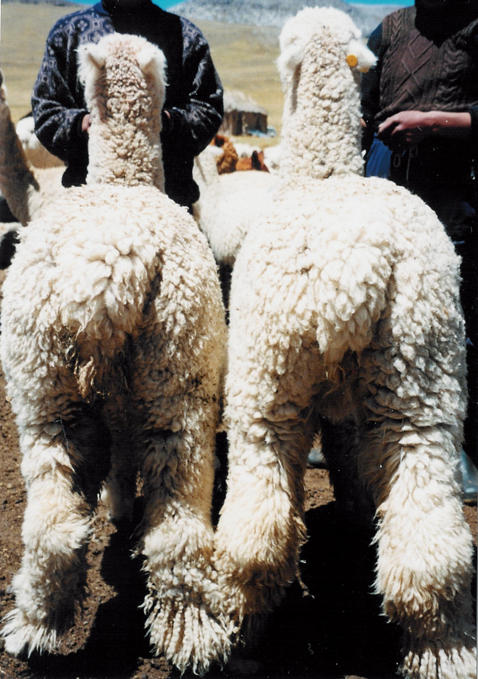
  Alpaca | Left | Right
  Primary fibre diameter  (microns) | 22.3 | 24.1
  Secondary fibre diameter  (microns) | 17.6 | 17.9
  Follicle density  (per mm2) | 54.8 | 43.8
  S/P ratio | 11.2 | 7.4
Fig. 3 Alpaca (left) has deeply crimped wool to fetlocks and exhibited clear markers indicating density and length. It is easy to right once there is a good understanding of the fleece markers. The breeder incorrectly favoured alpaca (right).

The “hand grab”, “touching both sides” and “lifting” density selection methods are inclined to produce the “false density” outcome exhibited in Figure 3 unless other visual and tactile characteristics are taken into account ie are the fibres highly aligned and bundling, and, handle, in short, the SRS® fleece markers.

The concept of “false density” is well understood by those implementing the SRS® Breeding System, because density is the most important criteria for an SRS® breeder to accurately assess. In the end it will determine viability of our industry in Australia. In summary therefore, an accurate determination of real density as determined by the SRS® fleece markers is critical for all serious alpaca breeders.

There are educational platforms where SRS® fleece markers can be identified and practiced are often held on farm, ‘hands on with the animals’ and fleeces, in a one-day hands-on workshop.

SRS® Fibre Breeding Goals

SRS® Alpaca Breeding System has set the goal of breeding alpacas of high fibre density and length (Watts and Hicks, 2002). This is expected to be an animal with a fibre density greater than 75 follicles per square millimetre, at least 63 follicles per group, with fine primary and secondary fibres of about 16 microns and totally free of any medullation. The fibres are expected to grow at the rate of at least 0.70 millimetres per day. Such animals should produce a fleece weight of at least 7.0 kilograms for 12 months growth and will require shearing twice a year.

Implementing the SRS® Alpaca Breeding System augmented by the availability of breeding technologies like embryo transfer (ET) and artificial insemination (AI) becoming commercially available, means that breeding numbers of SRS® Alpacas will be a reality sooner rather than latter.
These forecasts will allow Australian alpaca owners and breeders working with these techniques in other newer markets to prosper financially from their alpaca investment from fibre production additional to income derived from other income streams the alpaca may invite.

References
Watts, J.E. and Janie Hicks (2002). The Soft Rolling Skin ® (SRS ®) breeding system for alpacas. The Australian Alpaca Industry National Conference Proceedings pp. 137-163. Moore, G.P.M., Jackson, N., Isaacs, K. and Brown, G. (1998). Pattern and morphogenesis in skin. J. theory. Biol. 191, 97-94.

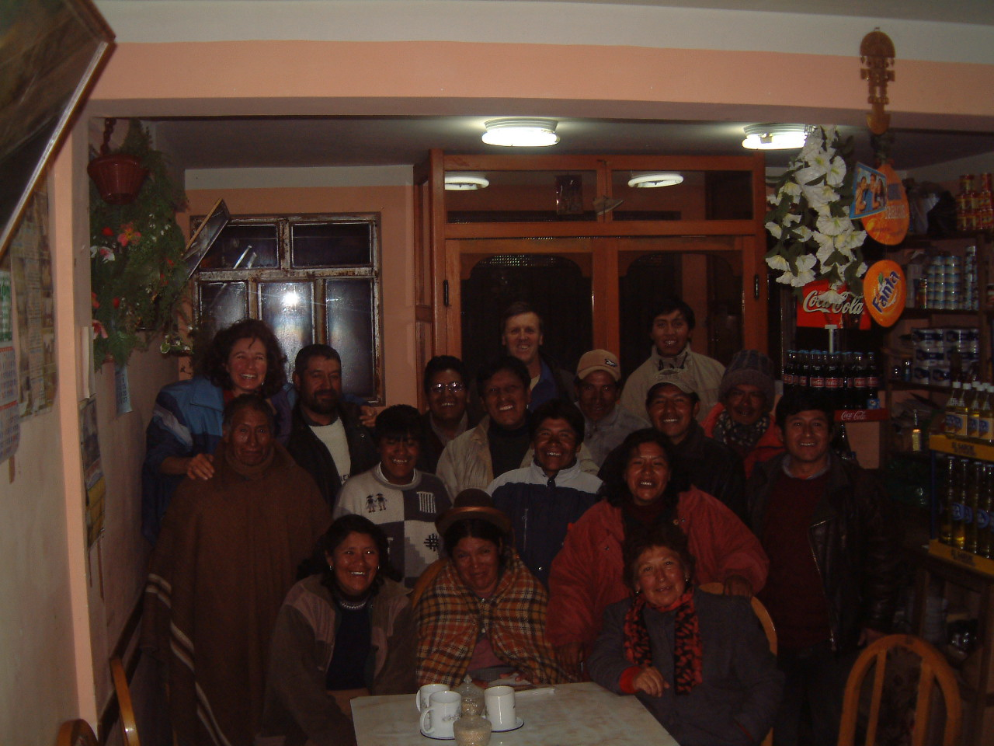.
Breeders of the Macusani Region 2003 when we returned with the results of the skintests of their animals from the 2001 study.

Thanks to all the breeders of Peru who assisted us in so many ways to complete our study, especially those from the Regions of Puno and Cuzco.

